Ozone Treatment Services
Advanced Supply Chain Group

INTRODUCTION
Sometimes shipments can arrive contaminated, leading to large claims, stock write-offs and a range of commercial issues for manufacturers, suppliers and retailers.
There is however, a fast and cost-effective solution available for consignments contaminated due to:
- Mould and damp
- Odour
- Smoke damage
- Migrant activity
- Insect infestation
Our ozone treatment service restores products to their original condition by:
- Neutralising odour
- Inactivating mould
- Improving biological safety

ADVANTAGES
- Products can be restored at a fraction of the product cost
- Large commercial volumes can be treated quickly
- Dry process leaving no chemical residue
- No colourfast or shrinkage issues
- Tags and labels are also treated and can remain on the product
- Product boxes and outer cartons can be treated, saved and reused
- Restoring products ensures that they remain within the supply chain and reach their
end destination within the selling window, thus minimising damages for all concerned

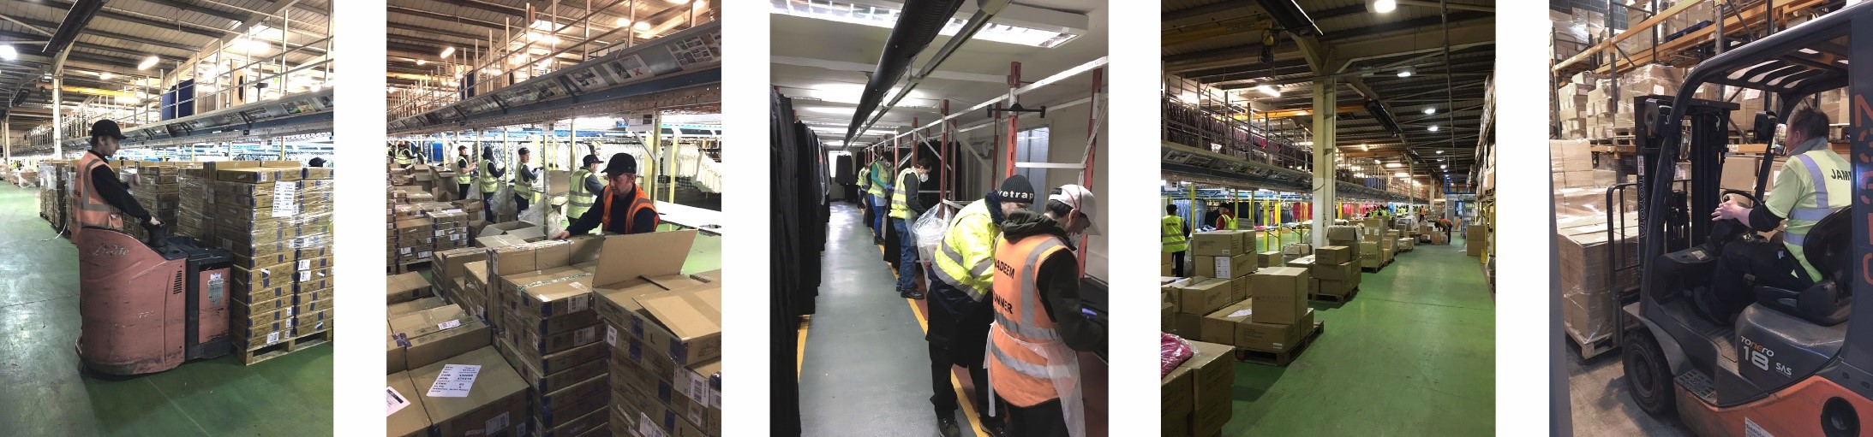
WHAT WE DO
We provide a specialist service that restores contaminated product back to a pristine, saleable condition.
Contaminated products are quarantined in our dedicated ozone facility where highly trained staff unpack, inspect and if required, clean and rectify each item. The product is then positioned ready for closely monitored, carefully controlled ozone exposure to sanitise the product and remove unwanted odours. Following ozone treatment, the product is repackaged to customer specifications and delivered to the required destination.

CAPACITY & CAPABILITIES
Product restoration is a labour intensive, complex technical process. Advanced Supply Chain Group has the necessary skills base and a scalable workforce ready to deal with peaks in demand for the service. Should product require any additional re-processing, all of our capabilities are readily available within the same facility.
We handle large commercial volumes of product per day. Our capacity is dictated by the size and type of product, by the nature of the problem itself and by the time-requirement for unpacking, inspecting, cleaning and repacking the product, so every case is unique. Customers are advised of lead times once samples have been received and assessed.
The service has been used successfully for the past 22 years and have successfully treated several million items, solving a wide range of problems found on consignments of clothing, footwear, accessories, homeware, and more for many of the UK’s most well-known brands and retailers.

OZONE TREATMENT EXPLAINED
Ozone treatment involves arranging products in a contained area and exposing them to a controlled dosage of gaseous ozone.
To explain the process in more detail, some fundamental points about ozone need to be discussed.
OZONE FORMATION
Ozone is a naturally occurring gas found in high concentrations in the stratosphere (the ozone layer).
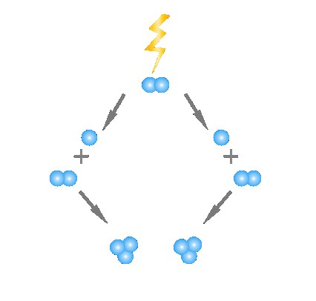
Atmospheric oxygen is converted to ozone when subjected to UV rays from the sun. Using an ozone generator, it is possible to mimic this natural process, substituting the sun’s radiation with a discharge of electricity.
The ozone generator passes air over electrodes that produce a dialectic barrier discharge, also known as corona discharge. The discharge causes oxygen molecules to separate into two oxygen atoms. The oxygen atoms then attach to other oxygen molecules, turning oxygen (O²) into ozone (O³).
In the example to the right, you can see three oxygen molecules in total. One oxygen molecule is split via electrical discharge, and the separated oxygen atoms attach to the other two oxygen molecules, resulting in the formation of two ozone molecules:
3O² -> 2O+2O² -> 2O³
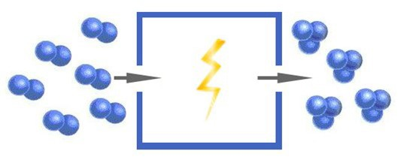
Ozone generators pass a continuous stream of oxygen through the generation unit. As the oxygen travels through the generator, it encounters dialectic barrier discharge electrodes which convert it into ozone, thus providing a constant supply of ozone at the exit point of the generator.
Using a series of ozone generators, we are able to produce a high volume of ozone, which is ducted and dispersed evenly throughout the treatment area. Products are positioned within the area in a manner that maximises exposure to the gas. The result is an area filled with products, each engulfed in an evenly dispersed, high concentration of gaseous ozone.

OZONE REVERSION
Ozone is a chemically unstable molecule, meaning that it will automatically revert to its most stable form. Ozone will naturally revert to oxygen over a period of time.
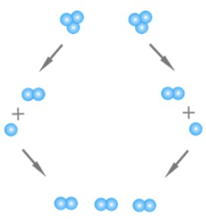
2O³ -> 2O+2O² -> 3O²
Ozone is therefore a dying gas. Its half-life is variable, dependent upon ambient conditions and the material composition of its environment. Ozone will oxidise most materials it encounters, varying by the material’s degree of susceptibility to oxidation.
With oxidation, ozone reversion accelerates. Oxidation occurs when the third oxygen atom breaks free and reacts with the material. So, in terms of material composition, ozone will revert to oxygen more slowly in the presence of 316 stainless steel than it will in the presence of natural rubber, because rubber is more susceptible to oxidation.
The reversion process is further accelerated in the presence of contaminants. When ozone meets a contaminant, the third oxygen atom breaks free and reacts with it. The oxidation reaction inactivates the contaminant, rendering it inert, and leaving O² as a byproduct.
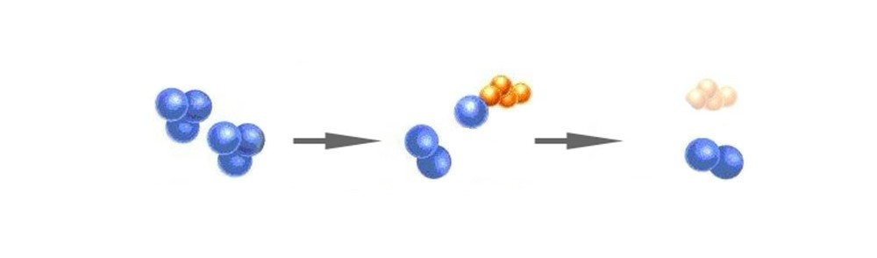

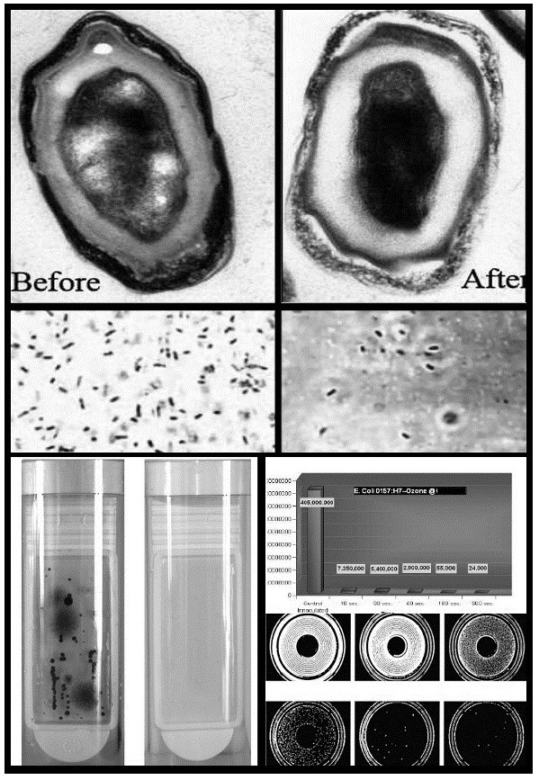
OZONE SANITISATION
The high oxidation potential of ozone makes it very useful when applied correctly. Unlike liquid or misted biocidal products produces a broad-spectrum of sanitising effects without leaving a chemical residue.
With correct usage, ozone can be used to good effect as a sanitising agent and is particularly beneficial in circumstances where dry processes are required.
Dry processing is what makes ozone our best practice solution for sanitising. It is the best option for the products, and also allows for
labels, tags, packaging and outer cartons to be sanitised and reused.

PROCESS CONTROL
Unlike traditional biocidal products that a pre-manufactured to a standard dosage, ozone is produced at source – so knowing the dosage being produced is critical.
Although ozone generators have a rated capacity to produce ozone (usually referenced in mg/hr or g/hr), the actual amount of ozone being produced and sustained by the generator varies widely, as with each treatment the ozone demand will be different. This is caused by the factors affecting the speed of ozone reversion, i.e. temperature, humidity, the material composition and contamination level of the target products.
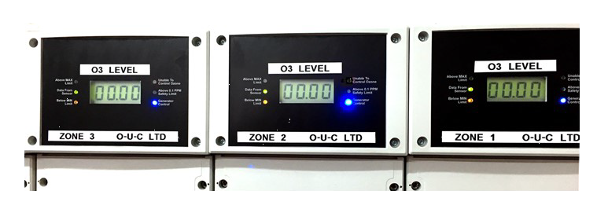
Simply running ozone generators in an area for a fixed time period will inevitably produce varied results. Without measurement it is impossible to see and account for the impact of the ozone demand. We therefore use ozone monitors and process controls to ensure the best possible treatment.
To ensure a safe and effective process, ambient environmental conditions and ozone levels are constantly monitored and controlled throughout the ozone treatment. Ozone levels in the area perimeter are also continually measured in line with our strict Health and Safety protocols.
The calibration of all ozone sensors is checked regularly using a UV photometric analyser. All ozone sensors are replaced on an annual basis, in line with the sensor manufacturer’s best practice guidelines.
All products are sample tested prior to bulk stock treatment to ensure their suitability for ozone treatment, and to determine a product-specific ozone treatment specification.

SAMPLE TESTING
Ozone is a powerful oxidant with a higher oxidation potential than chlorine. Products vary in material composition, so they have differing levels of tolerance to ozone exposure and not all products are suitable for treatment. However, it is usually possible to modify the treatment delivery specification to enable the successful treatment of most product types.
Sample testing is therefore conducted to determine a product-specific treatment specification prior to conducting treatments on bulk stock. We generally require at least 5 samples for testing – if the product is packaged in outer cartons, then one full carton would be preferred.
At sampling stage, time and motion studies are conducted to determine the labour cost of unpacking, positioning for treatment and re-packing the stock. Ozone area fill quantities, layout and workflow ergonomics are also assessed, enabling ASCG to determine an accurate cost and lead time.
When the product assessment is complete, customers receive a product test report, a quotation and lead time for completing the work, allowing for fully informed decisions to be made on how best to proceed. Samples are also returned to the customer for their own assessment of the result of the process.
Typical turnaround from receipt of samples is in most cases less than 48 hours. Sample testing is conducted free of charge to ensure customers are able to assess the effectiveness and economic viability of using our product restoration service without incurring any cost.

CONTACT
If you have any immediate issues with contaminated product, please contact:
Fabian Brierley
(National Sales Manager — Advanced Supply Chain Group)
Email: fabian.brierley@advancedsupplychain.com
Mobile: 07976 083 189
www.advancedsupplychain.com
Fabian will discuss your specific problem and product with you and make arrangements for assessment of samples.

